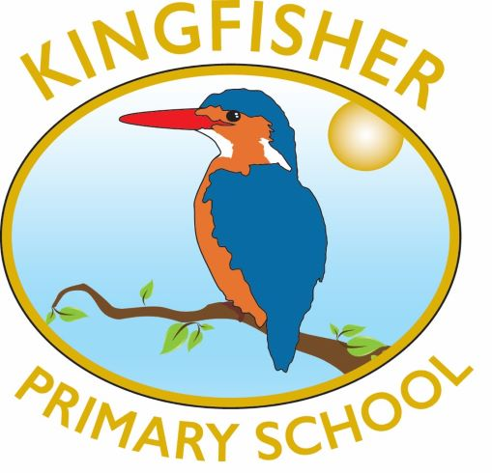
Year: R Class: Minnows Teacher: Miss Jackson (Mrs Huggins Teaching this unit outside.) Term: Autumn A

Topic: Creating Harvest Faces

Objectives:
I can experiment with and explore different textures.
I can experiment with and explore colour mixing with primary colours.
I can develop scissor skills and investigate cutting different materials.
I can learn how to plan and select the correct resources needed to make a model.
I can explore different ways to temporarily join materials together.
I can explore a pumpkin and describe it using the five senses.
I can learn how to use a knife safely.
Skills:
Mark making and drawing using a range of mediums eg; pens, pencils, crayons, etc.
Develop accuracy in drawing
Blend colour for a purpose
Change water when needed
Keep area tidy
Weave
Decorate fabric using a variety of techniques
Using scissors independently
Explore malleable materials
Evaluate their own work and make improvements
Use a variety of joining techniques
Construct sculptures
Collage
Work discreetly from observation and imagination
Choose their own resources and tools
Create their own designs
Pass scissors safely.
Lesson | Learning Objective | Key Skills | Vocabulary | Activities
1 | I can experiment with and explore different textures.  I can learn how to plan and select the correct resources needed to make a model.  I can explore objects and describe them using the five senses. | Mark making and drawing using a range of mediums eg; pens, pencils, crayons, etc.  Develop accuracy in drawing  Evaluate their own work and make improvements  Work discreetly from observation and imagination  Choose their own resources and tools  Create their own designs | Eyes, ears, mouth, nose, forehead, cheeks, skin, eyebrows, eyelashes, hair.  Smooth, spikey, rough, etc  Sticks, pine cones, stones, leaves, bark, etc. | Sing heads shoulders knees and toes to remind us about face parts.  Play Simon says – touch parts of face.  Sit in pairs and look at each others faces – have a go at drawing each other on clip boards.  Find different resources in the outside area and make a whole class face together inside the log circle.  Talk about the textures and shapes of the different materials they find and how they will be good for different parts of a face.
2 | I can experiment with and explore different textures.  I can learn how to plan and select the correct resources needed to make a model. | Evaluate their own work and make improvements  Construct sculptures  Collage  Work discreetly from observation and imagination  Choose their own resources and tools  Create their own designs | Eyes, ears, mouth, nose, forehead, cheeks, skin, eyebrows, eyelashes, hair.  Smooth, spikey, rough, etc  Seeds, sunflower, pumpkin, poppy, etc. | Explore a range of seeds together talk about what they look like and feel like. Tell them what each seed grows – match the seeds to the crops on pictures around the outside area.  Use the seeds to make pictures of faces on large sheets of paper outside. Children to have a go at taking photos of the faces themselves.  Children to talk about their faces and why they chose different seeds for different face parts.
3 | I can experiment with and explore different textures.  I can learn how to plan and select the correct resources needed to make a model.  I can explore vegetables and describe them using the five senses. | Evaluate their own work and make improvements  Collage  Work discreetly from observation and imagination  Choose their own resources and tools  Create their own designs | Eyes, ears, mouth, nose, forehead, cheeks, skin, eyebrows, eyelashes, hair.  Smooth, spikey, rough, etc  Vegetable names | Explore vegetables together and name the different vegetables. Talk about where the vegetables grow. Look at pictures of crops growing and match the vegetables to the pictures. Explore them using senses and talk about what they feel, smell and taste like etc.  In small groups make face pictures with the vegetables in the ground outside. Photograph their faces using the ipad.
4 | I can experiment with and explore different textures.  I can experiment with and explore colour mixing with primary colours.  I can learn how to plan and select the correct resources needed to make a model.  I can explore fruits and describe them using the five senses. | Mark making and drawing using a range of mediums eg; pens, pencils, crayons, etc.  Blend colour for a purpose  Evaluate their own work and make improvements  Collage  Work discreetly from observation and imagination  Choose their own resources and tools  Create their own designs | Eyes, ears, mouth, nose, forehead, cheeks, skin, eyebrows, eyelashes, hair.  Smooth, spikey, rough, etc  Fruit names | Explore fruits together and name the different fruits. Talk about where the fruits grow. Look at pictures of crops growing and match the fruits to the pictures.  Demonstrate and explore colour mixing using just the primary colours.  Fruit and vegetable printing to make faces on large roll of paper outside. Talk about the shapes of the fruit and veg and why they would be good for different parts of faces.
5 | I can experiment with and explore different textures.  I can develop scissor skills and investigate cutting different materials.  I can learn how to plan and select the correct resources needed to make a model.  I can explore different ways to temporarily join materials together.  I can explore a pumpkin and describe it using the five senses.  I can learn how to use a knife safely. | Mark making and drawing using a range of mediums eg; pens, pencils, crayons, etc.  Using scissors independently  Explore malleable materials  Evaluate their own work and make improvements  Use a variety of joining techniques  Construct sculptures  Work discreetly from observation and imagination  Choose their own resources and tools  Create their own designs  Pass scissors safely. | Eyes, ears, mouth, nose, forehead, cheeks, skin, eyebrows, eyelashes, hair.  Smooth, spikey, rough, etc  Clay, round, long, short, etc | Show the children the clay/salt dough that we are going to use today.  Have a go at making different shapes together. (Do some dough disco to build strength in their hands. Use a range of tools to cut the clay – scissors, knives etc.  Clay/saltdough faces on tree trunks using different natural outdoor resources to create features on the faces.
6 | I can explore a pumpkin and describe it using the five senses.  I can learn how to use a knife safely. | Using hand drill independently  Explore malleable materials  Evaluate their own work and make improvements  Construct sculptures  Work discreetly from observation and imagination  Choose their own resources and tools | Eyes, ears, mouth, nose, forehead, cheeks, skin, eyebrows, eyelashes, hair.  Smooth, spikey, rough, etc  Pumpkin, smooth, soft, squishy, juicy etc. | Explore pumpkin together using all senses.  Pumpkin faces. Children to use the hand drills to make eyes and mouth in the pumpkins for faces.  Potential family session???  If this goes ahead:  Learn to light fires and cook pumpkin seeds  Pumpkin faces  Showing their parents how to make clay tree faces

Links to PSHE which are integral in all outdoor learning sessions: Year R SCARF ‘I can’ statements:

I can be kind, caring and helpful to others.
I can show good listening
I can say how to stay safe in the home, classroom and outside.
I can help to clean and tidy my home and classroom.
I can be kind to friends and others.
I can keep trying if the way I choose doesn't work.
I can tell you some ways to look after our world.
I can talk about the different types of feelings we have.
I can have a go at something new.

